**Week – 13 - Passing arrays and strings to functions**

**Reg no : 241001159**

**Name : PADHMAVATHY.M**

**Q1)**

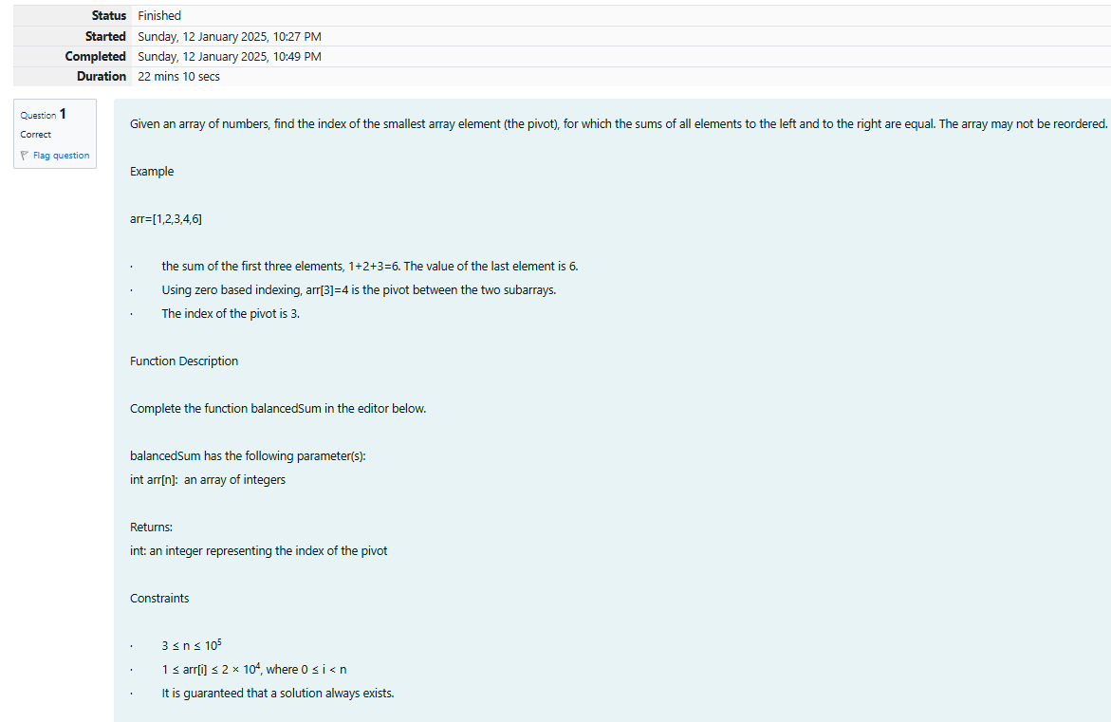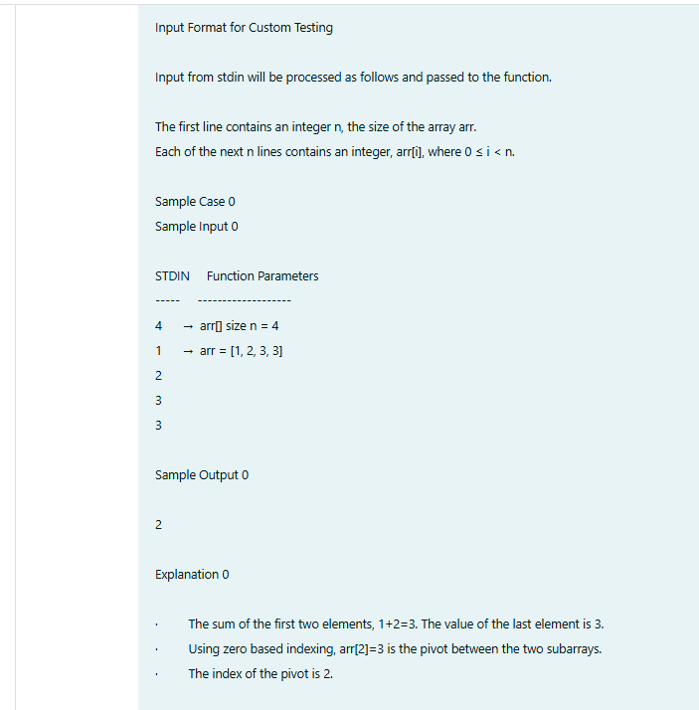

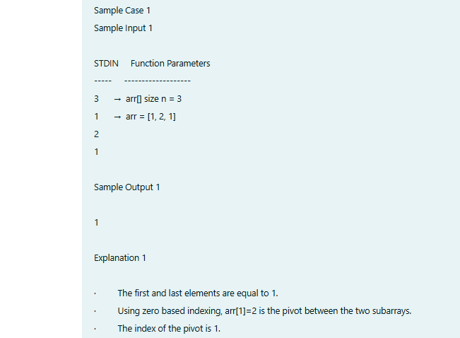

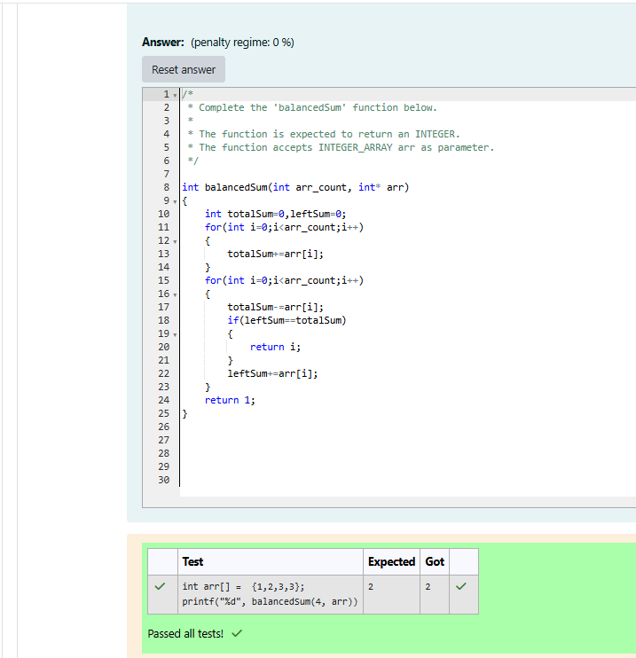

**Reg no : 241001159**

**Name : PADHMAVATHY.M**

**Q2)**

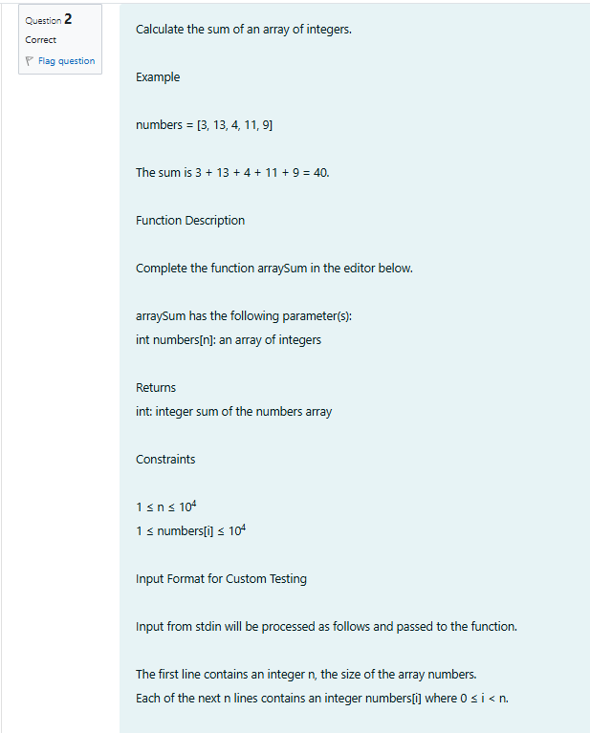

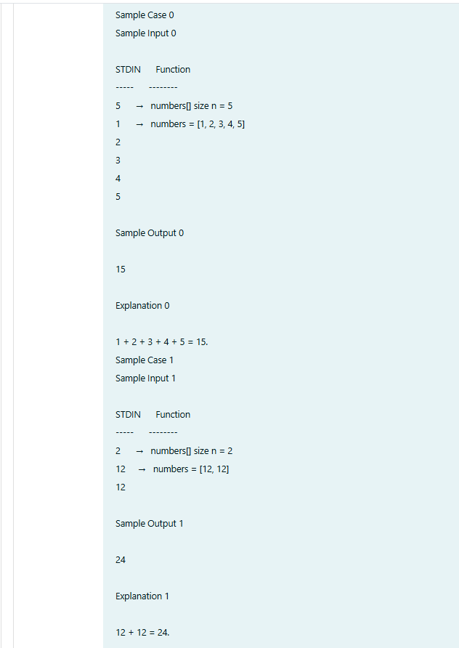

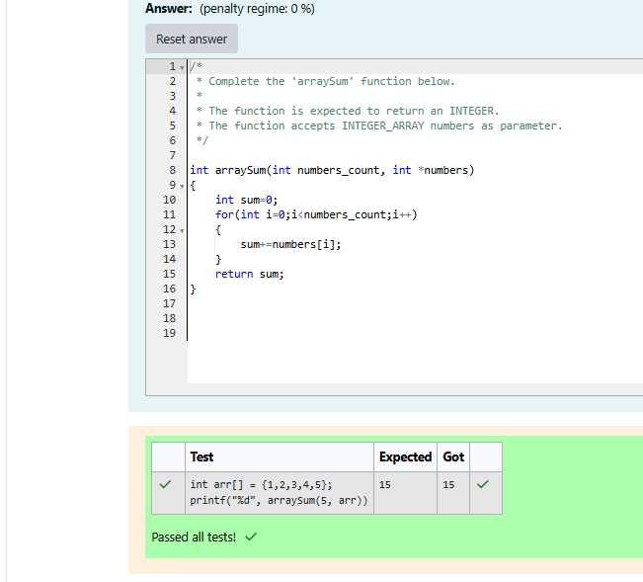

**Reg no : 241001159**

**Name : PADHMAVATHY.M**

**Q3)**

